QuickPed System Blueprint: Authentication & Authorization Module
Authors: N.Yashwanth Bala , Saikrishna
Phase 1: AUTHENTICATION AND AUTHORIZATION MODULE

1. Executive Summary: The Passwordless Workflow
QuickPed utilizes a frictionless, 3-tier passwordless authentication system. The system determines access and pricing tiers dynamically based on verification status.
Architecture Context: User → PWA (Flutter) → APIs (NestJS) → Database (PostgreSQL) → External (Twilio/SendGrid)

Authentication Lifecycle
- 1. Entry: The user opens the PWA and submits their mobile number.
- 2. Phone OTP: The backend generates a 6-digit OTP, stores it securely in PostgreSQL, and dispatches it via Twilio SMS.
- 3. Guest Verification: The user submits the OTP. The backend executes an atomic upsert in PostgreSQL. Upon creation, the user defaults to GUEST_RIDER and is issued a stateless JSON Web Token (JWT).
- 4. Campus Assignment: The user submits their display name and selects a Campus, updating their core profile data.
- 5. Verified Upgrade (Optional): To access student pricing, the user submits an institutional email. The backend dispatches an OTP via SendGrid. Upon successful verification, the account role permanently upgrades to VERIFIED_RIDER and new JWT is issued.

2. Infrastructure Dependencies
- Twilio API Keys: Required for routing SMS OTPs to mobile numbers.
- SendGrid API Keys: Required for routing institutional email OTPs.
- Supabase Database URI: Required to host the PostgreSQL database.

2.1 Authentication Sequence Diagram
The following sequence illustrates the data flow for the core phone authentication phase.

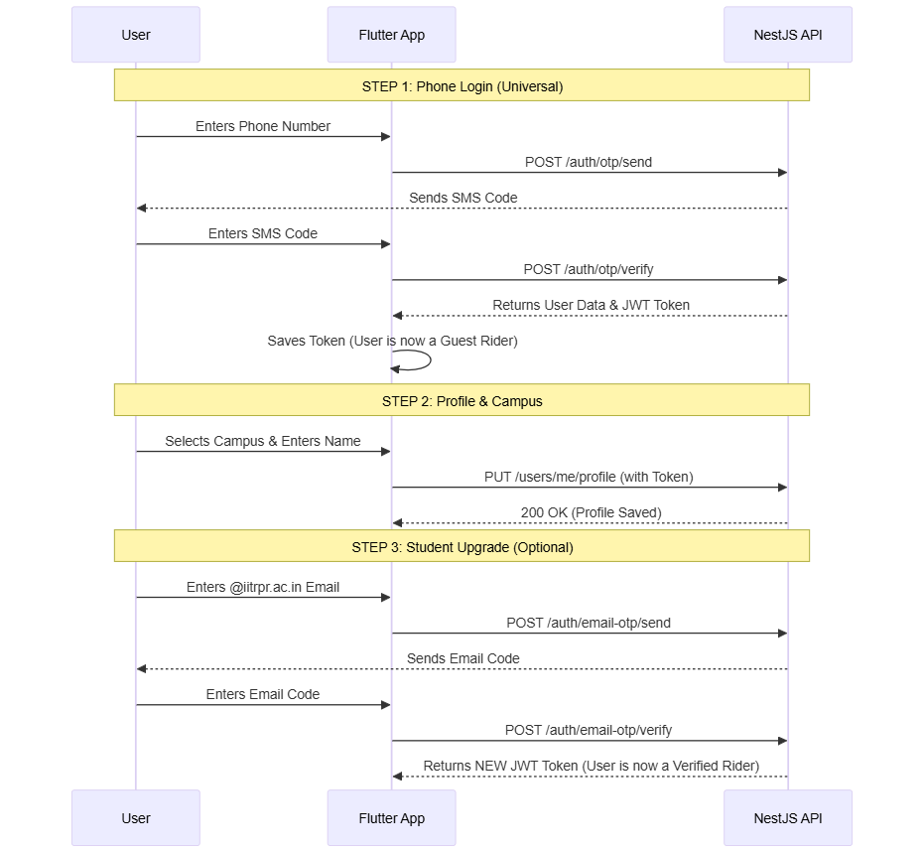

3. Database Schema Architecture
To support state management across multiple server instances without Redis, a dedicated OtpTracker table handles concurrency natively.
// User Model
model User {
id String @id @default(dbgenerated("gen_random_uuid()")) @db.Uuid
phoneNumber String @unique
name String?
institutionalEmail String? @unique
role Role @default(GUEST_RIDER)
walletBalance Decimal @default(0.00) @db.Decimal(10, 2)
campusId String? @db.Uuid
createdAt DateTime @default(now())
updatedAt DateTime @updatedAt
campus Campus? @relation(fields: [campusId], references: [id])
}
// Campus Model (
model Campus {
id String @id @default(dbgenerated("gen_random_uuid()")) @db.Uuid
name String
config Json // Stores map URLs and pricing rules dynamically
users User[]
}
// OTP Tracker
model OtpTracker {
identifier String @id // Phone number or email
otpCode String
expiresAt DateTime
lastRequestAt DateTime @default(now())
attempts Int @default(0)
}
enum Role {
GUEST_RIDER
VERIFIED_RIDER
ADMIN
}

4. Engineering Solutions: Security & Concurrency
As we are initially not using Redis, the system requires native database safeguards to mitigate multi-server scaling risks.
- Multi-Click Race Conditions (Duplicate OTPs): The identifier column in OtpTracker serves as the Primary Key. The /verify logic utilizes Prisma's upsert command. In the event of simultaneous parallel requests, PostgreSQL's row-level locking guarantees the row is updated exactly once.
- Rate Limiting & Bot Protection: Prior to OTP generation, the backend evaluates OtpTracker.lastRequestAt. If now() < lastRequestAt + certain configured seconds(like 60 seconds), the API rejects the request with HTTP 429 (Too Many Requests) to prevent API abuse and toll fraud.
- Brute Force Mitigation: The system tracks verification failures in OtpTracker.attempts. If attempts >= 3, the current OTP is cryptographically invalidated, forcing the client to request a new code.

5. API Handshake Contracts
All payloads and responses utilize strict JSON. Base URL: /api/v1.

Phase 1: Phone Login
POST /auth/otp/send
- Purpose: Initiates login and triggers Twilio SMS.
Request:
{
"phoneNumber": "+919772347890"
}
Success (200):
{
"status": "success",
"message": "OTP sent."
}
Error (429):
{
"error": "Please wait 60 seconds before requesting a new OTP."
}
POST /auth/otp/verify
- Purpose: Verifies OTP and returns the authentication JWT.
Request:
{
"phoneNumber": "+919876543210",
"otpCode": "123456"
}
Success (200):
{
"status": "success",
"token": "eyJhbGciOi..."
}

Phase 2: Profile & Campus Selection
PUT /users/me/profile
- Purpose: Assigns display name and binds the user to a campus.
- Headers: Authorization: Bearer <token>
Request:
{
"name": "jhon",
"campusId": "uuid-of-iit-ropar"
}
Success (200):
{
"status": "success",
"message": "Profile updated."
}

Phase 3: Verified Rider Upgrade
POST /auth/email-otp/send
- Purpose: Dispatches SendGrid OTP to the institutional email.
- Headers: Authorization: Bearer <token>
Request:
{
"email": "student@iitrpr.ac.in"
}
Success (200):
{
"status": "success",
"message": "Email OTP sent."
}
POST /auth/email-otp/verify
- Purpose: Upgrades user role and issues an escalated JWT.
- Headers: Authorization: Bearer <token>
Request:
{
"email": "student@iitrpr.ac.in",
"otpCode": "123456"
}
Success (200):
{
"status": "success",
"token": "new_escalated_jwt_here"
}

6. Frontend State Management & JWT Rules
The Flutter PWA must strictly implement the following client-side policies:
- Stateless Architecture: The backend maintains zero session state. The client must securely persist the JWT in local storage (e.g., Flutter Secure Storage or Hive) and update it accordingly.
- API Interceptor: All authenticated REST requests must inject the token via the Authorization: Bearer <token> header.
- Dynamic Role Upgrades: Upon successful response from /auth/email-otp/verify, the client must explicitly overwrite the existing JWT in local storage with the newly returned token. This updates the internal role claim to VERIFIED_RIDER, unlocking UI access to student pricing.
- Token Expiration Lifecycle: Tokens expire after 30 days. The frontend must implement a global interceptor to catch HTTP 401 Unauthorized responses, purge local storage, and forcefully route the user to the initial phone login screen.

